
SCHOOL OF COMPUTING AND ENGINEERING SCIENCES (SCES)
BACHELOR OF SCIENCE IN ELECTRICAL AND ELECTRONICS
ENGINEERING (BSEEE)
CONTROL SYSTEMS 2
Lab 4:
STORAGE TANK LIQUID LEVEL CONTROL USING A PLC
BY
Edward Mwongela
(GROUP 5)

Lecturer: Prof. Jackson Mbuthia
29th October 2024

Table of Contents
List of figures 2
1. Title: 3
2. Objective: 3
3. Learning Outcome: 3
4. Homework to be done as group work. 4
I. Introduction 4
II. Programmable Storage Tank Liquid Level Control Preparations 5
5. Practical Experiment 9
6. Lab Report 9

List of figures
Figure 1. liquid level control 4
Figure 2. Allen-Bradley Micro810 PLC CPU 4
Figure 3. float switch 4

Title:
Storage Tank Liquid Level Control Using a Programmable Logic Controller

Objective:
- Use a programmable controller output to control a pump
- Use the tank level on/off switches as inputs to the programmable controller

Learning Outcome:
- Learn how to implement a simple closed loop Bang-Bang controller using a programmable controller.
- Understand the advantages of using a programmable controller to control a pump.

Homework to be done as group work.

Introduction
Fig. 1 shows the tank filling arrangement. The sensors shown are implemented using the float switch shown in Fig.2. The float switches are connected to the input terminals of the Micro810 PLC shown in Fig. 4 and the pump motor supply is connected to the output terminals of the Micro810 PLC.
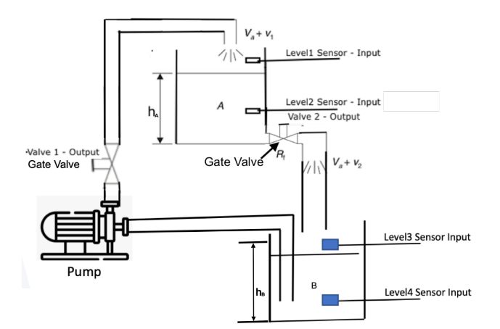
Figure 1. liquid level control
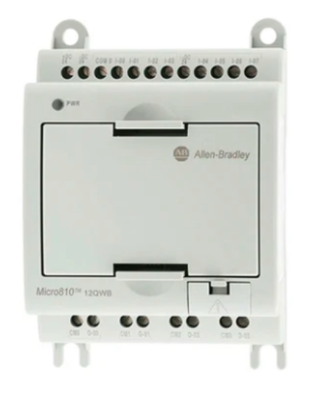
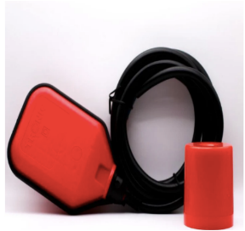
Figure 2. Allen-Bradley Micro810 PLC CPU
Figure 3. float switch

Programmable Storage Tank Liquid Level Control Preparations
To learn how to program and upload code into the Micro810 PLC, you can download the latest version of Connected Components Workbench for your Micro800 at the URL below.
http://www.rockwellautomation.com/global/products-technologies/connectedcomponents/
You will need to create a free account to access the documentation.
- Physically Confirm that the name plate ratings of the Micro810 PLC supplied to you allow its direct connection to the 240AC mains and the outputs relay contacts have the adequate current and voltage ratings to drive the pump motor and write down the appropriate ratings.
- Refer to the Micro810 PLC Connected Components Work Bench manuals here to prepare a wiring diagram showing the float switches connected as inputs of the Micro810 PLC and the Pump Motor supply connected to the Micro810 PLC outputs.
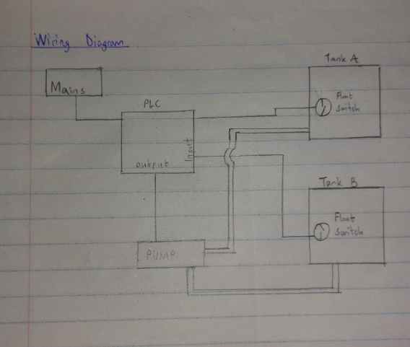
- Refer to the Connected Components Work Bench Manuals here to write a program to override float switches and run pump for 2 minutes.
PROGRAM PumpControl
VAR
FloatSwitch1 : BOOL; // Input for Float Switch 1
FloatSwitch2 : BOOL; // Input for Float Switch 2
Pump : BOOL; // Output for Pump
ManualOverride : BOOL; // Manual Override Input
PumpTimer : TON; // Timer for 2 minutes
END_VAR
// Set the timer duration to 2 minutes
PumpTimer(IN := FALSE, PT := T#2m);
// Pump Control Logic
IF (NOT FloatSwitch1 AND NOT FloatSwitch2) OR ManualOverride THEN
IF NOT PumpTimer.Q THEN
Pump := TRUE; // Activate pump
PumpTimer(IN := TRUE); // Start the timer
END_IF;
ELSE
Pump := FALSE; // Deactivate pump if float switches indicate full and override is off
PumpTimer(IN := FALSE); // Reset the timer
END_IF;
// Check Timer Done Status
IF PumpTimer.Q THEN
Pump := FALSE; // Stop pump when timer is done
PumpTimer(IN := FALSE); // Reset the timer for future cycles
END_IF;
END_PROGRAM
- Refer to the Connected Components Work Bench Manuals here to write a program to override float switch for Tank A but only run the pump for 2 minutes when Tank B switch is ON.
PROGRAM TankAControl
VAR
FloatSwitchTankA : BOOL; // Input for Float Switch of Tank A
FloatSwitchTankB : BOOL; // Input for Float Switch of Tank B
Pump : BOOL; // Output for Pump
ManualOverrideTankA : BOOL; // Manual Override Input for Tank A
PumpTimer : TON; // Timer structure for 2 minutes
END_VAR
// Initialize timer
PumpTimer(IN := FALSE, PT := T#2m); // 2 minutes timer
// Pump Control Logic
IF ManualOverrideTankA THEN
IF FloatSwitchTankB THEN
Pump := TRUE; // Activate pump only if Tank B switch is ON
PumpTimer(IN := TRUE); // Start timer
ELSE
Pump := FALSE; // Deactivate pump if Tank B switch is OFF
PumpTimer(IN := FALSE); // Stop timer
END_IF;
ELSE
Pump := FALSE; // Deactivate pump if override is not active
PumpTimer(IN := FALSE); // Stop timer
END_IF;
// Check Timer Done Status
IF PumpTimer.Q THEN
Pump := FALSE; // Stop pump when timer is done
END_IF;
END_PROGRAM
- Refer to the Connected Components Work Bench Manuals here to write a program to override float switch for Tank B but only run the pump for 2 minutes when Tank A switch is ON.
PROGRAM TankAControl
VAR
FloatSwitchTankA : BOOL; // Input for Float Switch of Tank A
FloatSwitchTankB : BOOL; // Input for Float Switch of Tank B
Pump : BOOL; // Output for Pump
ManualOverrideTankA : BOOL; // Manual Override Input for Tank A
PumpTimer : TON; // Timer for 2 minutes
END_VAR
// Set the timer duration to 2 minutes
PumpTimer(IN := FALSE, PT := T#2m);
// Pump Control Logic
IF ManualOverrideTankA AND FloatSwitchTankB THEN
IF NOT PumpTimer.Q THEN
Pump := TRUE; // Activate pump
PumpTimer(IN := TRUE); // Start the timer
END_IF;
ELSE
IF NOT PumpTimer.Q THEN
Pump := FALSE; // Deactivate pump if conditions are not met
PumpTimer(IN := FALSE); // Reset the timer
END_IF;
END_IF;
// Check Timer Done Status
IF PumpTimer.Q THEN
Pump := FALSE; // Stop pump when timer is done
PumpTimer(IN := FALSE); // Reset the timer for future cycles
END_IF;
END_PROGRAM
- Refer to the Connected Components Work Bench Manuals here to write a program to run the pump only when both Tank A and Tank B float switches are ON.
PROGRAM TankABControl
VAR
FloatSwitchTankA : BOOL; // Input for Float Switch of Tank A
FloatSwitchTankB : BOOL; // Input for Float Switch of Tank B
Pump : BOOL; // Output for Pump
END_VAR
// Pump Control Logic
IF FloatSwitchTankA AND FloatSwitchTankB THEN
Pump := TRUE; // Activate pump if both float switches are ON
ELSE
Pump := FALSE; // Deactivate pump if either switch is OFF
END_IF;
END_PROGRAM
Upload your preparations on the drive before doing the lab.

Practical Experiment
This will be posted later.

Lab Report
1. Use these guidelines https://guides.libraries.indiana.edu/c.php?g=992698&p=7182653 to write your individual lab report detailing your answers for sections 1 to 4.

